SWINBURNE VIETNAM
HO CHI MINH CAMPUS


COS30018 - COS30018-Intelligent Systems
Week 10: Task C.5

INSTRUCTOR: MR. KY TRUNG PHAM
STUDENT NAME: LÊ TIẾN DŨNG-SWS00683

HO CHI MINH CITY – MAR-2026

Contents
1. Overview of what I implemented 3
2. Dynamic DL Model Builder Function (Requirement 1) 3
2.1 Purpose 3
2.2 Function inputs and outputs (what it takes and returns) 3
2.3 Less straightforward lines (key code reasoning) 4
2.4 References used Error! Bookmark not defined.
3. Experiment Setup 4
3.1 Controlled settings (kept constant) 4
3.2 Variables tested 4
3.3 Evaluation metrics 5
4. Results Summary (6 runs) Error! Bookmark not defined.
4.1 Config A — epochs=25, batch_size=64 Error! Bookmark not defined.
4.2 Config B — epochs=32, batch_size=50 Error! Bookmark not defined.
5. Discussion Error! Bookmark not defined.
5.1 Accuracy comparison Error! Bookmark not defined.
5.2 Training speed comparison Error! Bookmark not defined.
5.3 Effect of changing batch size and epochs Error! Bookmark not defined.
6. Conclusion Error! Bookmark not defined.

1. Overview of what I implemented

After completing Task C.4 (v0.3), the code base was upgraded to version v0.4 to solve more advanced forecasting problems:
- Multistep prediction: predict a sequence of future closing prices for k days ahead.
- Multivariate prediction: use multiple features (Open, High, Low, Close, Adj Close, Volume) as input to predict the future Close price.
- Multivariate + multistep prediction: combine both—use multivariate inputs to predict k future Close prices.
I implemented new functions and modifications to my data processing and model pipeline to support these scenarios and validated them by running three modes: multistep, multivariate, and multivariate_multistep.

2. Implementation Summary (Functions Required by Task C.5)

2.1 Multistep prediction
Goal: predict the next k closing prices instead of only the next day.
To achieve this, I modified the dataset sequence-building logic so that the label y becomes a vector of length k:
- Single-step: y[i] is one value (Close at time t+1).
- Multi-step: y[i] becomes [Close(t+1), Close(t+2), …, Close(t+k)].
Key change: the model output layer must match the label shape:
- Dense(1) for single-step
- Dense(k) for multistep.
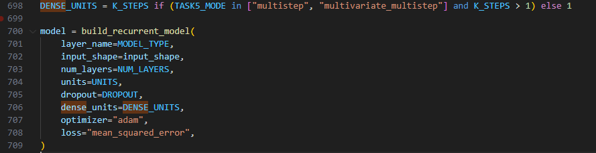

2.2 Simple multivariate prediction
Goal: use multiple features of the same company as input to predict Close in the future.
I extended the feature list to include:

- Open, High, Low, Close, Adj Close, Volume
This makes the input tensor:
$$X∈R^{(samples, lookback, n_{features})}$$
In my case, n_features = 6.
The target remains Close (single-step prediction), but now the model learns from a richer representation of market behavior including intraday range and trading activity.

2.3 Multivariate + multistep
Goal: combine the above two:
- input: multiple features (6 features)
- output: a sequence of k future Close prices
This produces:
- X_train shape = (samples, lookback, 6)
- y_train shape = (samples, k)
- model output layer = Dense(k)
(d) Dense(1) output for regression
Stock prediction here is regression (predicting a continuous price), so the output layer is Dense(1).

3. Less Straightforward Code Lines

3.1 Building multistep labels safely (indexing logic)
A key challenge was correctly indexing the future target window:
- define the start of prediction: target_start = i + forecast_horizon - 1
- define the end of prediction: target_end = target_start + (k_steps - 1)
This prevents out-of-bound indexing and ensures each training sample has a valid k-day label vector.

3.2 Keeping the model output compatible with y shape
For multistep, the model output must be a vector. That required:
- setting dense_units = k_steps
- ensuring predictions return shape (samples, k_steps)
This is the main conceptual difference between single-step and multistep regression models.
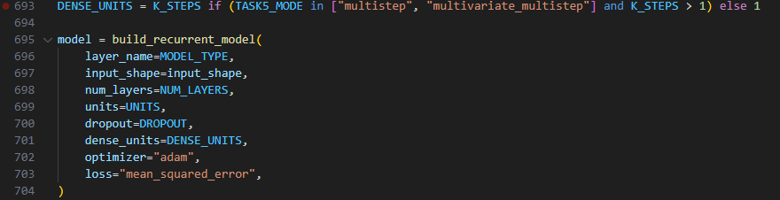

3.3 Inverse transform for multistep outputs (scaler handling)
Because the target scaler is fit on one column (Close), but the prediction is (samples, k), I used a reshape strategy:
- flatten predictions to (-1, 1)
- inverse transform with the scaler
- reshape back to (samples, k)
This prevents errors and ensures predictions are converted back into real price units.

3.4 Handling “Adj Close” column differences in yfinance
Some tickers / cached datasets can return OHLCV without "Adj Close". To satisfy the assignment’s required feature list while maintaining compatibility, I implemented a safe fallback:
- if "Adj Close" is missing, use "Close" as a proxy and log a warning.
This ensures the code runs consistently and the input feature dimension remains correct
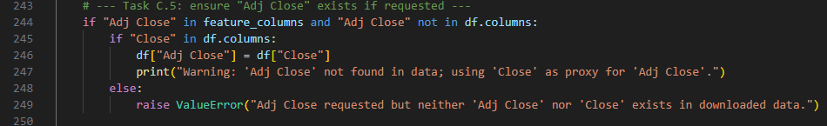

3.5 Plotting multistep predictions clearly
When k > 1, plotting a full matrix (samples, k) results in multiple predicted lines. To keep the chart readable, I plotted only t+1 (the first horizon), and labeled it as t+1 of k.

4. References Used
- TensorFlow/Keras RNN documentation (stacking RNNs and output shapes):
https://www.tensorflow.org/api_docs/python/tf/keras/layers/LSTM
https://www.tensorflow.org/api_docs/python/tf/keras/layers/GRU
https://www.tensorflow.org/api_docs/python/tf/keras/layers/SimpleRNN
- scikit-learn MinMaxScaler (fit/transform and inverse_transform):
https://scikit-learn.org/stable/modules/generated/sklearn.preprocessing.MinMaxScaler.html
- yfinance documentation/examples (feature availability varies by ticker):
https://pypi.org/project/yfinance/

5. Experiment Results Summary (Multistep / Multivariate / Combined)
I tested three modes on CBA.AX with the same lookback window (60 days) and evaluated results using MAE/MSE/RMSE. A saved terminal with all the tested results have been save in Result-ScreenShots folder.

5.1 Mode A — Multistep (univariate, Close only, k=5)
- Output: Next 5-day prediction vector
- Reported metrics (from logs):
  - MAE: 2.1189
  - RMSE: 2.6793
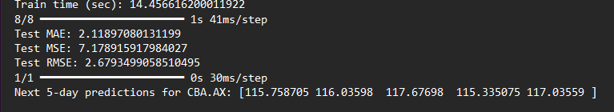

5.2 Mode B — Multivariate (single-step, 6 features)
- Output: Next-day prediction scalar
- Reported metrics:
  - MAE: 2.8345
  - RMSE: 3.4370
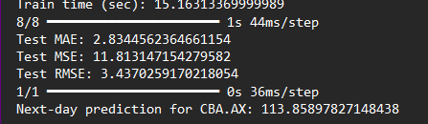

5.3 Mode C — Multivariate + Multistep (6 features, k=5)
- Output: Next 5-day prediction vector
- Reported metrics:
  - MAE: 4.9349
  - RMSE: 5.6959
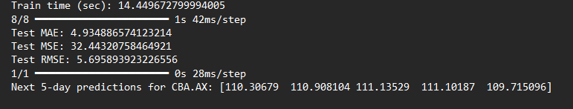
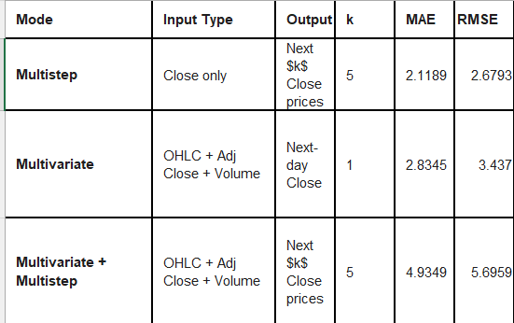
Discussion
- The combined problem (multivariate + multistep) is the hardest, so higher MAE/RMSE is expected because it must learn richer inputs while forecasting multiple steps ahead.
- Multistep forecasting also increases uncertainty because errors can grow across horizons.

6. Conclusion
Task C.5 successfully extended the project to v0.4 by supporting:
- multistep prediction (predict k future days),
- multivariate prediction (use multiple features as input),
- multivariate multistep prediction (combine both).
The implementation required careful handling of label construction, output shape alignment (Dense(k)), correct inverse-transform logic for multistep outputs, and practical data column compatibility (Adj Close). The experiments demonstrate that the system can run all three modes and produce valid evaluation metrics.

